Template 12: Community Survey for the First Peoples’ Cultural Council (FPCC) Language Status Assessment (LSA)

What is an LSA?
The Language Status Assessment (LSA) is a survey on the status of First Nations languages. The LSA should be completed by a designated representative of a First Nations community located in B.C.

Why is the LSA important?
- The LSA helps communities document and track information such as the number of fluent speakers, semi-speakers, learners and more.
- Completing LSAs every four years allows communities to see how these numbers change over time to assess whether their language programs are working or could be improved.
- LSAs assist communities with language planning.
- The data collected in the LSA is shared in the Report on the Status of B.C. First Nations Languages and the information supports FPCC to advocate for increased funding for First Nations languages.
- The information also helps FPCC understand which language strategies are resulting in the best outcomes, identify areas that may need urgent support and demonstrate the growing vitality of languages across B.C.

What is this template for?
The main part of the LSA asks about the number of fluent speakers, semi-speakers and learners in your community. If you would like to survey your own community to collect the answers you need for the LSA, you can use this template.

Where can I find more information about how to conduct a survey?
Check out chapter 2 of A Guide to Language Policy and Planning for B.C. First Nations Communities: http://www.fpcc.ca/language/Programs/Language_Policy_Guide.aspx

Instructions
- Edit the template on page 3 to personalize it for your community.
- You may want to add additional questions to your survey. You can find more survey templates in the guide linked above. Word versions of the templates in the guide can be found on our website (https://fpcc.ca/resource/).
- Distribute the survey on p. 3-4 to each household and collect surveys after the deadline.
- If you don’t receive surveys from everyone, it can be helpful to give people a call to collect the information over the phone.
- Alternatively, you might want to do the whole survey by phone and collect responses that way, entering the data as you make each call.
- We have resources available to help you summarize your results.
- For example, we have created an easy-to-use Google form that you can use for entering your data. Once all of the survey data has been entered, you can create quick-and-easy charts to summarize the results, like the following examples:

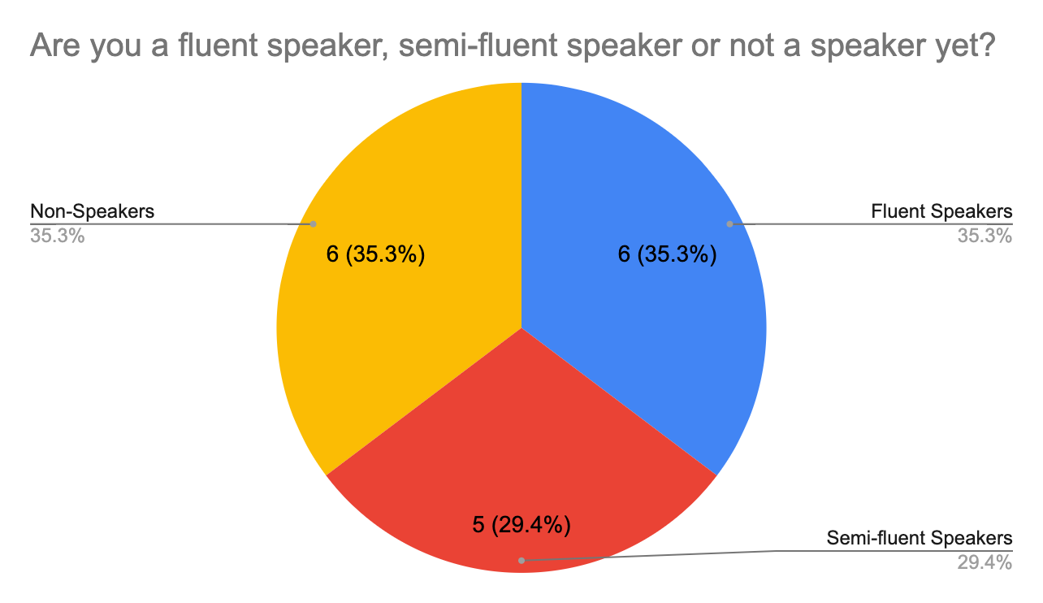

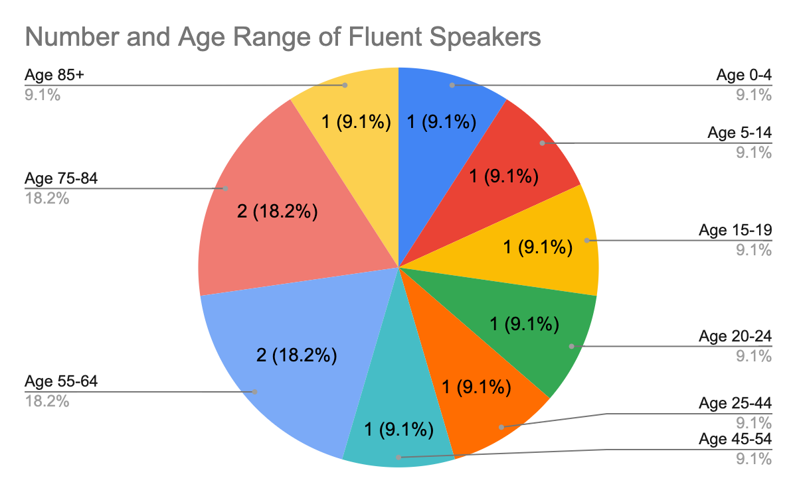

- If you would like assistance with entering and summarizing your survey data, contact us at lsa@fpcc.ca.

Community Language Survey for First Nation

Our community is conducting this survey for [LANGUAGE NAME] to help with planning language programs.
Please fill out this survey by [DUE DATE: 1-2 weeks suggested]

On the following page, please list each person living in your household and answer 3 questions:
1. Is this person a speaker?
2. How old is this person?
3. Is this person currently learning the language?

Please begin by reading the following definitions.

Fluent Speakers: Fluent speakers have the ability to converse and understand the language with no use of English. Usually this means that the language is their mother tongue, meaning it was the first language they learned as a child. However, many individuals in B.C. have become highly fluent adult speakers of their language, though English was their mother tongue.

Semi-fluent Speakers (including silent speakers): Semi-speakers can speak and understand their language to some degree. This definition allows for great variability. Semi-speakers may be able to have a conversation in certain settings but can't talk about everything. Silent speakers who understand but don’t actively speak can be counted as semi-speakers. Semi-speakers may also include people who learned to speak as a second language (not mother tongue) if they don't consider themselves fully fluent.

Non-Speakers: Non-speakers are people who don’t speak yet, but it is never too late to learn, and no one should ever blame themselves for not speaking their language. Non-speakers may know some words or phrases in a language but are not able to have simple conversations.

Language Learners: A learner is anyone in the process of learning her or his language by participating in any type of language learning method, program or class. (It does not have to be in a formal educational setting.) “Learners” is a separate category that overlaps with non-speakers, semi-speakers or even fluent speakers who may still consider themselves learners.

Fluent speakers + Semi-fluent speakers + Non-speakers = Total Population
Learners are part of this population. Learners may be
non-speakers, semi-fluent speakers or fluent speakers.

Name | Is this person a speaker?  (Check one) |  |  | How old is this person? (Check one) |  |  |  |  |  |  |  |  |  | Is this person currently learning?  (Circle Yes/No)
Name | Fluent Speaker | Semi-Speaker | Not a speaker yet | Age 0-4 | Age 5-14 | Age 15-19 | Age 20-24 | Age 25-44 | Age 45-54 | Age 55-64 | Age 65-74 | Age 75-84 | Age 85 + | Is this person currently learning?  (Circle Yes/No)
 |  |  |  |  |  |  |  |  |  |  |  |  |  | YES | NO
 |  |  |  |  |  |  |  |  |  |  |  |  |  | YES | NO
 |  |  |  |  |  |  |  |  |  |  |  |  |  | YES | NO
 |  |  |  |  |  |  |  |  |  |  |  |  |  | YES | NO
 |  |  |  |  |  |  |  |  |  |  |  |  |  | YES | NO
 |  |  |  |  |  |  |  |  |  |  |  |  |  | YES | NO
 |  |  |  |  |  |  |  |  |  |  |  |  |  | YES | NO
 |  |  |  |  |  |  |  |  |  |  |  |  |  | YES | NO
 |  |  |  |  |  |  |  |  |  |  |  |  |  | YES | NO
 |  |  |  |  |  |  |  |  |  |  |  |  |  | YES | NO

